1. *Find the Marginal Distribution p(x)*

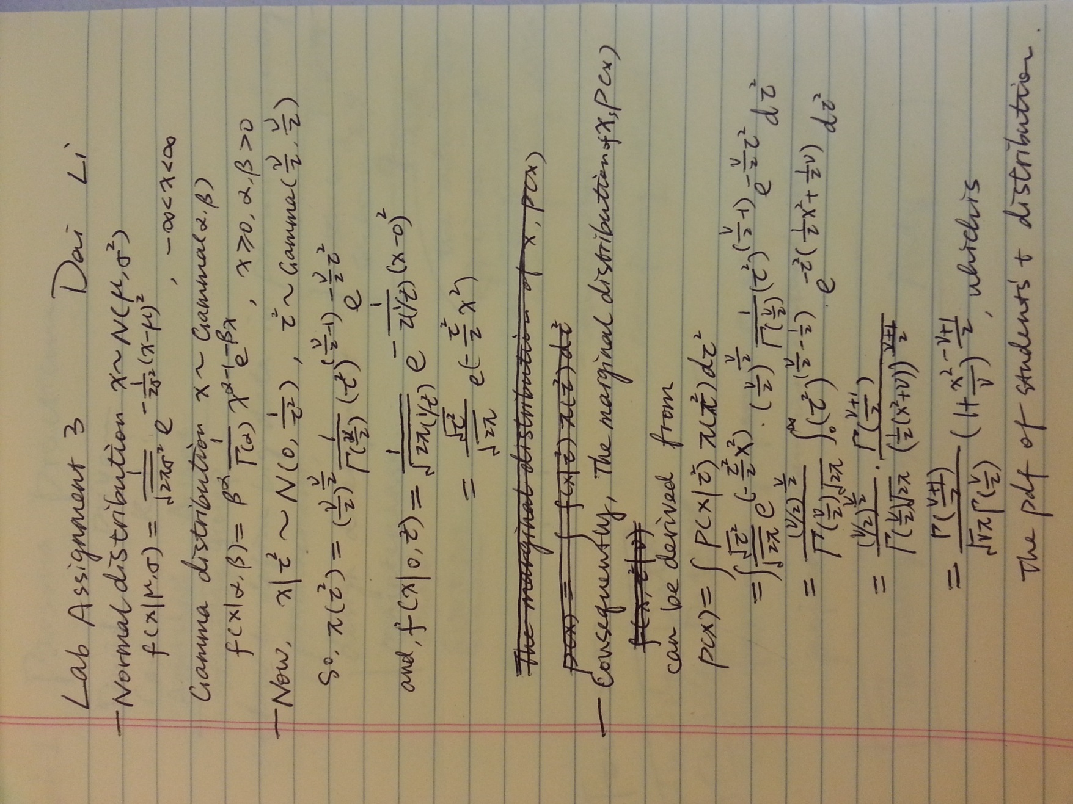

2. *Let nu=1. Get a sample of 10,000 from marginal distr. of x by drawing 10,000 tau^2's and then 10,000 x's given the tau^2's. Plot sample (either histogram or density is fine). Give two names for the actual marginal distribution p(x) when nu=1. Also, compute 2.5% & 97.5% percentile points of the distribution using the random samples and compare them to the theoretical values.*

The actual marginal distribution p(x) when nu=1 is plotted below:

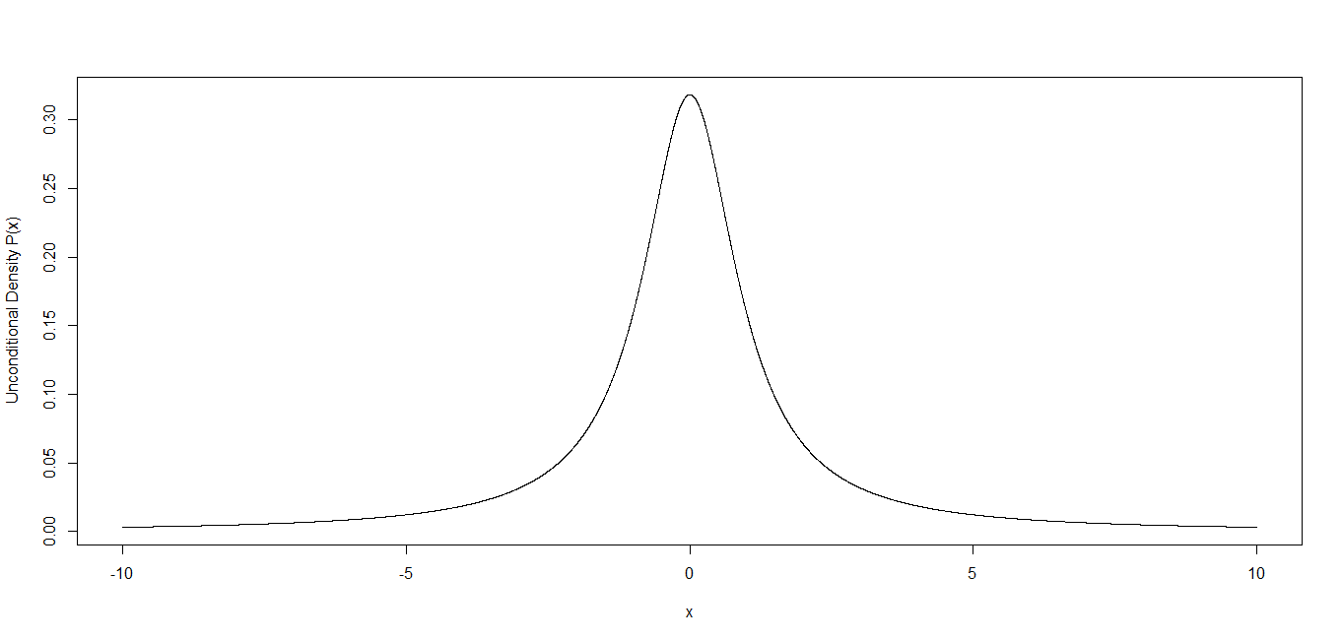

Which is a **Students’ T Distribution with parameter Nu=1**. As, Nu=1, it is also a Cauchy Distribution with location parameter=0 and a scale parameter.

While using the 10000 sample points, we can draw out the theoretical conditional density of p(x|tau.square), which is plotted below:

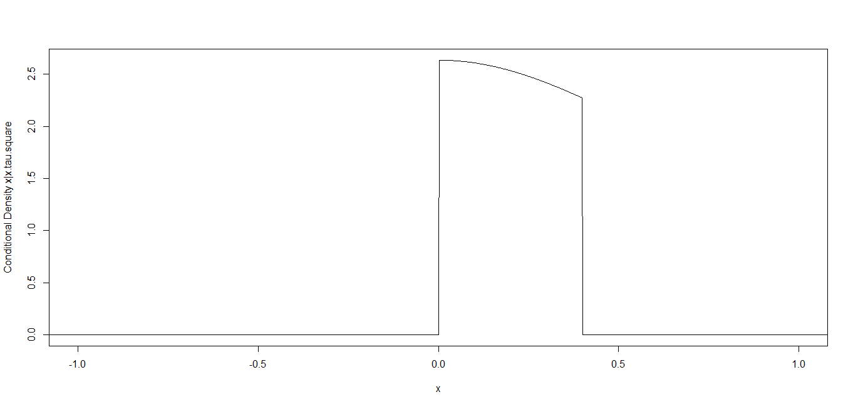

Which is a Student’s T distribution truncated to [min(x.tau.square.sample), max(x.tau.square.sample)], whose p(x)sample value histogram is also plotted below:



The 2.5% & 97.5% percentile points of theoretical p(x) are ***(-12.7062, 12.7062).*** While, the 2.5% & 97.5% percentile points of sampled p(x) are ***(0.009560445, 0.3877215).***

3*. Use Kolmogorov-Smirnov test (ks.test in R) to test whether your observed distribution is equal to a t(df=1). Report p-value. What is the conclusion of the test?*

Under null-hypothesis, p-value < 2.2e-16,

Using the sample points, D= 0.5853.

Conclusion of the test: R eject the hypothesis-***the observed distribution is not equal to a t(df=1).***

4. *Does the Central Limit Theorem hold for the mean of a sample from p(x) when nu=1? What about nu=2? nu=3? Why or why not? A quick explanation will do; an involved proof is NOT required.*

Given nu=1,2,or 3, there are finite value of X, so that there are finite value of mean E(x) and variance Var(x), and thus, the Central Limit Theorem hold for the sampled p(x).

Code:

theta=seq(0,100,length=10001);nu=1

tau.square <- dgamma(theta,(nu/2),(nu/2))

x=seq(-10,10,length=10001)

x.tau.square <- dnorm(0,1/tau.square)

marginal.p.unconditional <- dt(x,nu)

marginal.p.conditional <- dt(x,nu)*as.numeric(x > min(x.tau.square) & x < max(x.tau.square))/(pt(max(x.tau.square),nu)-pt(min(x.tau.square),nu))

#draw 10000 samples

theta.sample <- runif(10000,0,1)

tau.square.sample <- dgamma(theta.sample,(nu/2),(nu/2))

x.tau.square.sample <- dnorm(0,1/tau.square.sample)

marginal.p.sample <- dt(x.tau.square.sample,nu)

#Plotting

par(mfrow = c(2,2))

plot(x,marginal.p.unconditional,xlim=c(-10,10),type="l",xlab="x",ylab="Unconditional Density P(x)")

plot(x,marginal.p.conditional,xlim=c(-1.0,1),type="l",xlab="x",ylab="Conditional Density x|x.tau.square")

hist(marginal.p.unconditional,breaks=10,plot=TRUE)

hist(marginal.p.sample,breaks=10,plot=TRUE)

#Calculating Credible Interval

truncated.inverse.cdf <- function(x,x.tau.square,nu){

F.a=pt(min(x.tau.square),nu)

F.b=pt(max(x.tau.square),nu)

z=qt((F.b-F.a)*x+F.a,nu)

return(z)

}

lower.theoretical <- qt(0.025,nu)

upper.theoretical <- qt(0.975,nu)

lower.actual <- truncated.inverse.cdf(.025,x.tau.square.sample,nu)

upper.actual <- truncated.inverse.cdf(.975,x.tau.square.sample,nu)

ks.test(marginal.p.sample,"pt",1)